**Contents**

* Acknowledgement
* Synopsis
* Working environment and requirements
* Concepts used
* Algorithm
* Header files used
* Source code
* Input and Output data
* Bibliography

**ACKNOWLEDGEMENT**

I would like to thank the SBOA JC Management and our Principal, **Mrs. Radhika Unni** for providing usair-conditioned laboratory facilities and without whom this project wouldn’t have been materialized.

I would like to express my heartfelt thanks to my computer science teacher and our class teacher,**Mrs.Geetha**. She has been a constant source of inspiration and motivation for all of us. I wouldn’t have been able to finish this project in the absence of her guidance.

I would also like to thank our Academic supervisor **Mrs. A.S.Visalakshi**, who had not only taught us to run programs, but also to run life in a positive way. Her presence during demonstration and debugging has no words to be expressed.

Finally, we also thank our computer lab Teacher, **Mrs.J.Revathi** for herunflagging patience, creativity and the immense knowledge which they she shared with us that is highly beneficial to our team.

Finally,I would like to thank my partner for hissupport in completing this project.

**SYNOPSIS**

Telephone directory is a vital for many in their day-to-day activities be it for a common man or a business man. For a business man, this telephone directory helps to promote business, manage customers and maintain good customer relationship. This telephone directory is significant for Customer Relationship Management (CRM) software or Sales software for all businesses.

The main aim of this project is to create a new telephone directory of the customers which helps to create, search, modify and delete the data according to the users wish.

Data management is important in everyday life for everyone. This has induced and motivated us to come up with a project like this.

**WORKING ENVIRONMENT AND REQUIREMENTS**

**Hardware Requirements:**

1. Monitor
2. Keyboard
3. Mouse

**Software Requirements:**

1. Operating System : Windows 7 & higher
2. Turbo C++ compiler with graphics
3. At least 44.0 KB of free space in RAM

**CONCEPTS USED**

1. Structure
2. Classes
3. Files
4. Loops
5. Arrays
6. Graphics
7. Pointers

**ALGORITHM**

|  |  |
| --- | --- |
| void input(); | Inputs the data from the user and stores the data in Telephone.dat file. |
| void display(); | Reads the data from the file Telephone.dat and the graphics function is called to display all the data in a tabular form |
| void insert(); | New data is given by the user and position is also given to insert in between. The existing data file Telephone.dat is read and then written in a temp.dat file. After the insertion done in “temp.dat” the file is renamed as “Telephone.dat” and the old file is removed |
| void search(); | Search’s the user entered customer id and displays all the details. |
| void delete1(); | Deletes the user entered customer id and writes the undeleted data in “Telephone2.dat”. Finally, Telephone2.dat is renamed as Telephone.dat, the Telephone2.dat is removed. Display function is called todisplay the data |
| void sort_num(); | Sorts the data according to Customer id and displays the details in ascending order using bubble sort and all the data are displayed |
| void modify(); | New data is entered by the user and the position is also mentioned to copy the new data and all the data area displayed |
| void graphics(); | A function which is designed by the user the output their data in a tabular form |

**HEADER FILES**

|  |  |
| --- | --- |
| FSTREAM.H | For file related operations of input/output and writing. |
| CONIO.H | To print and create text based User interface |
| STDIO.H | Standard input and output functions |
| PROCESS.H | For functions like exit(); |
| IOSTREAM.H | General header file for C++ having operations to print |
| STRING.H | Handling string manipulation |
| GRAPHICS.H | For interactive user-interface |
| STDLIB.H | General purpose |
| CTYPE.H | Library declares several functions that are useful for testing and mapping characters (to change cases either upper or lower) |

**SOURCE CODE**

/* AISSCE Board Practicals 2020

Computer Science(083) – Project

Telephone directory*/

#include<conio.h>

#include<fstream.h>

#include<graphics.h>

#include<stdlib.h>

#include<stdio.h>

#include<string.h>

#include<process.h>

struct tele

{

char name [50];

long int no;

char add[50];

char city[30];

long cust_id;

}T;

class telephone

{

public:

void input();

void display();

void insert();

void search();

void delete1();

void sort_num();

void modify();

void graphics();

}t;

int n;

int r=0;

void telephone::input()

{

fstream f;

f.open("Telephone.dat",ios::out|ios::binary);

gotoxy(4,5);

cout<<"Enter the size:-";

cin>>n;

cout<<"---------------------\n"<<endl;

for(int i=0;i<n;i++)

{

cout<<"Enter the customer id:"<<endl;

cin>>T.cust_id;

cout<<"Enter the name:"<<endl;

gets(T.name);

cout<<"Enter the no:"<<endl;

cin>>T.no;

cout<<"Enter the address:"<<endl;

gets(T.add);

cout<<"Enter the city:"<<endl;

gets(T.city);

cout<<"---------------------\n";

f.write((char*)&T,sizeof(T));

}

f.close();

cleardevice();

}

void telephone::display()

{

int n=4,m=20;

cleardevice();

telephone t1;

int x=90,y=100;

t1.graphics();

fstream f1;

tele T1;

f1.open("Telephone.dat",ios::in|ios::binary);

while(!f1.eof())

{

char ch[25],ch1[25];

f1.read((char*)&T1,sizeof(T1));

gotoxy(n,m);

ultoa(T1.cust_id,ch,10);

ultoa(T1.no,ch1,10);

outtextxy(x-40,y,ch);

outtextxy(x+20,y,T1.name);

outtextxy(x+100,y,ch1);

outtextxy(x+245,y,T1.add);

outtextxy(x+430,y,T1.city);

m=m+6;

y=y+20;

}

f1.close();

getch();

}

void telephone::sort_num()

{

telephone t2;

gotoxy(4,5);

int x=90,y=100,n=4,m=5;

char ch[25],ch1[25];

fstream f7;

f7.open("Telephone.dat",ios::in|ios::binary);

tele T[50];

int i=0;

while(!f7.eof())

{

f7.read((char*)&T[i],sizeof(T[i]));

i++;

}

f7.close();

for(int j=0;j<i;j++)

{

for(int k=0;k<i-j-1;k++)

{

if(T[k].cust_id>T[k+1].cust_id)

{

tele temp;

temp=T[k];

T[k]=T[k+1];

T[k+1]=temp;

}

}

}

for(int h=0;h<i;h++)

{

gotoxy(n,m);

t2.graphics();

ultoa(T[h].cust_id,ch,10);

ultoa(T[h].no,ch1,10);

outtextxy(x-40,y,ch);

outtextxy(x+20,y,T[h].name);

outtextxy(x+100,y,ch1);

outtextxy(x+245,y,T[h].add);

outtextxy(x+430,y,T[h].city);

m=m+6;

y=y+20;

}

getch();

}

void telephone::insert()

{

tele c5,T3;

long int a;

gotoxy(4,5);

cout<<"Enter the new student info:"<<endl;

cout<<"Enter the New customer_id:";

cin>>c5.cust_id;

cout<<"New Name:";

gets(c5.name);

cout<<"Enter the new Number:";

cin>>c5.no;

cout<<"Enter the new address:";

gets(c5.add);

cout<<"Enter the new city:";

gets(c5.city);

cout<<"Enter the Customer_id before which the new info must to inserted:";

cin>>a;

fstream f7("Telephone.dat",ios::binary|ios::in);

fstream f8("temp.dat",ios::binary|ios::app);

for(int i=0;i<n;i++)

{

f7.read((char*)&T3,sizeof(T3));

if((T3.cust_id!=a))

{

f8.write((char*)&T3,sizeof(T3));

}

else

{

f8.write((char*)&c5,sizeof(c5));

f8.write((char*)&T3,sizeof(T3));

}

}

f7.close();

f8.close();

n++;

remove("Telephone.dat");

rename("temp.dat","Telephone.dat");

}

void telephone::search()

{

telephone t2;

int a;

gotoxy(4,5);

cout<<"Enter the Customer id to be searched:";

cin>>a;

fstream fs;

tele T1;

int x=90,y=100,n=2,m=20;

int flag=0;

char ch[25];

char ch1[30];

fs.open("Telephone.dat",ios::in|ios::binary);

while(!fs.eof())

{

fs.read((char*)&T1,sizeof(T1));

if(T1.cust_id==a)

{

cleardevice();

t2.graphics();

gotoxy(n,m);

ultoa(T1.cust_id,ch,10);

ultoa(T1.no,ch1,10);

outtextxy(x-40,y,ch);

outtextxy(x+20,y,T1.name);

outtextxy(x+100,y,ch1);

outtextxy(x+245,y,T1.add);

outtextxy(x+430,y,T1.city);

flag=1;

}

}

if(flag==0)

{

cout<<"Not found"<<endl;

}

fs.close();

getch();

}

void telephone::delete1()

{

tele T1;

int b;

gotoxy(4,5);

cout<<"Enter the Customer_id to be deleted:-";

cin>>b;

fstream f4,f5;

f4.open("Telephone.dat",ios::in|ios::binary);

f5.open("Telephone2.dat",ios::out|ios::binary);

int flag1=0;

while(!f4.eof())

{

f4.read((char*)&T1,sizeof(T1));

if(T1.cust_id!=b)

{

f5.write((char*)&T1,sizeof(T1));

flag1=1;

}

}

if(flag1==0)

{

cout<<"Not found"<<endl;

}

f4.close();

f5.close();

remove("Telephone.dat");

rename("Telephone2.dat","Telephone.dat");

}

void telephone::modify()

{

fstream f6;

int y;

gotoxy(4,5);

cout<<"Enter the position to be modified:-";

cin>>y;

char a[50];

char b[50];

char c[40];

int h;

int d;

cout<<"Enter the Customer id"<<endl;

cin>>d;

cout<<"Enter the name:"<<endl;

gets(a);

cout<<"Enter the number:"<<endl;

cin>>h;

cout<<"Enter the address:"<<endl;

gets(b);

cout<<"Enter the city:"<<endl;

gets(c);

cout<<"---------------------\n";

f6.open("Telephone.dat",ios::in|ios::out|ios::binary);

while(!f6.eof())

{

int pos=f6.tellg();

f6.read((char*)&T,sizeof(T));

if(y==T.cust_id)

{

T.cust_id=d;

strcpy(T.add,b);

strcpy(T.name,a);

T.no=h;

strcpy(T.city,c);

f6.seekg(pos);

f6.write((char*)&T,sizeof(T));

}

}

f6.close();

}

void telephone::graphics()

{

int a;

int xmax, ymax;

setcolor(getmaxcolor());

xmax = getmaxx();

ymax = getmaxy();

settextstyle(TRIPLEX_FONT, HORIZ_DIR, 5);

line(0,0,getmaxx(),0);

outtextxy(100,10,"TELEPHONE DIRECTORY");

line(0,60,getmaxx(), 60);

settextstyle(SANS_SERIF_FONT,HORIZ_DIR,2);

outtextxy(0,70,"\tCUS_ID\t\tNAME\t\t\tNUMBER\t\t\t\tADDRESS\t\t\t\tCITY");

line(0,0,0,370);

line(100,60,100,370);

line(180,60,180,370);

line(310,60,310,370);

line(500,60,500,370);

line(0,100,xmax,100);

line(xmax,0,xmax,370);

getch();

}

void main()

{

clrscr();

int gdriver=DETECT,gmode;

initgraph(&gdriver, &gmode,"c://turboc3//bgi");

settextstyle(SANS_SERIF_FONT,HORIZ_DIR,5);

outtextxy(80,10,"TELEPHONE DIRECTORY");

settextstyle(SANS_SERIF_FONT,HORIZ_DIR,3);

outtextxy(380,300,"DONE BY:-");

outtextxy(440,330,"V.ASWIN KUMAR");

outtextxy(440,357,"M.HEMACHANDRIAN");

getch();

cleardevice();

int ch;

char ch1;

do

{

settextstyle(SANS_SERIF_FONT,HORIZ_DIR,2);

gotoxy(4,5);

outtextxy(10,10,"MENU");

outtextxy(10,33,"----");

outtextxy(20,50,"1.To get data");

outtextxy(20,80,"2.To display");

outtextxy(20,110,"3.To insert ");

outtextxy(20,140,"4.To search ");

outtextxy(20,170,"5.To delete ");

outtextxy(20,200,"6.To sort ");

outtextxy(20,230,"7.To modify the data");

outtextxy(20,260,"8.Exit");

outtextxy(20,300,"Enter the choice(1-10)");

gotoxy(4,23);

cin>>ch;

switch(ch)

{

case 1:

cleardevice();

t.input();

break;

case 2:

cleardevice();

t.display();

break;

case 3:

cleardevice();

t.insert();

break;

case 4:

cleardevice();

t.search();

break;

case 5:

cleardevice();

t.delete1();

break;

case 6:

cleardevice();

t.sort_num();

break;

case 7:

cleardevice();

t.modify();

break;

case 8:

cleardevice();

exit(0);

break;

default:

cleardevice();

cout<<"Invalid";

break;

}

gotoxy(24,25);

cleardevice();

outtextxy(40,370,"press Y / y:-");

cin>>ch1;

cleardevice();

}while (ch1=='Y'||ch1=='y');

closegraph();

getch();

}

**INPUT AND OUTPUT DATA**

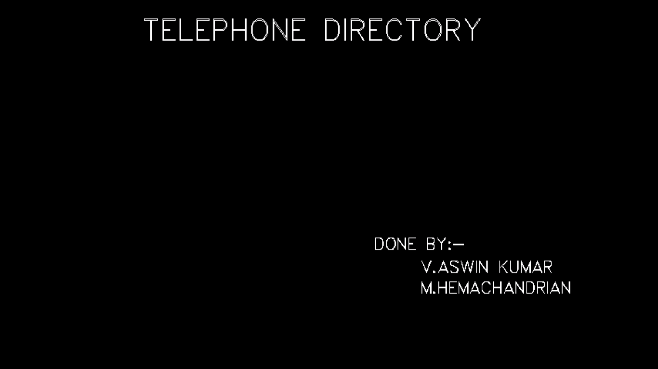

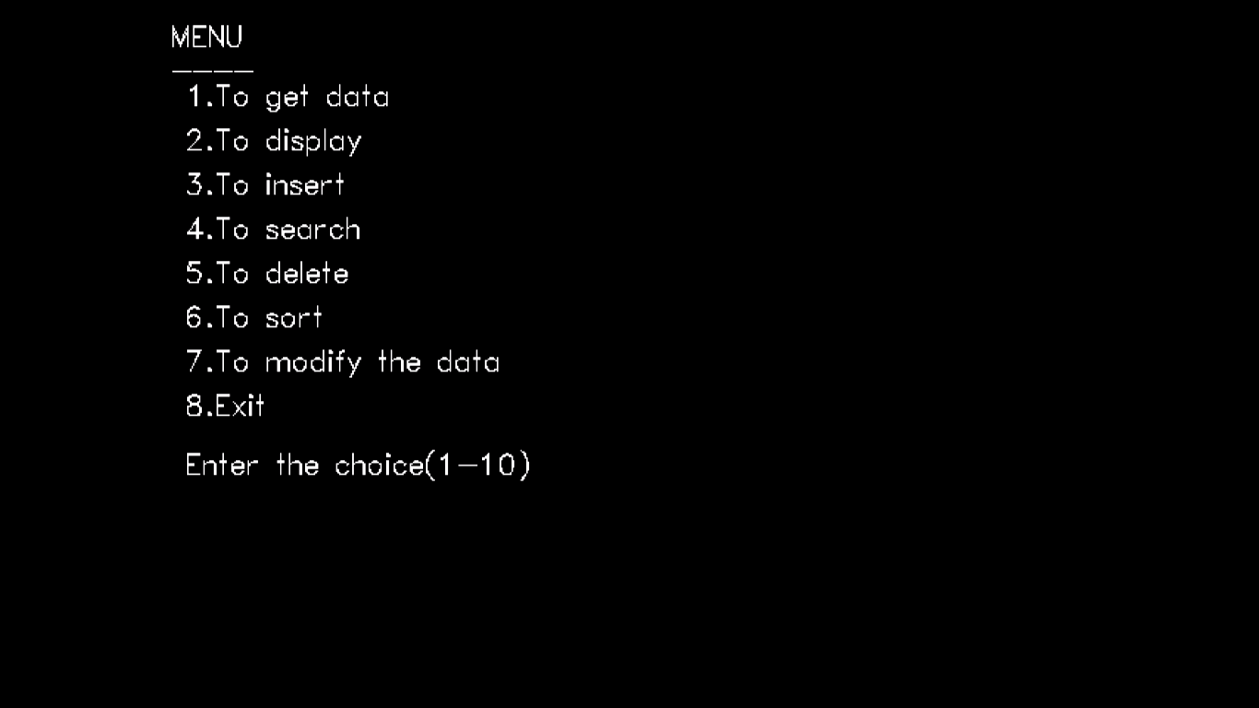

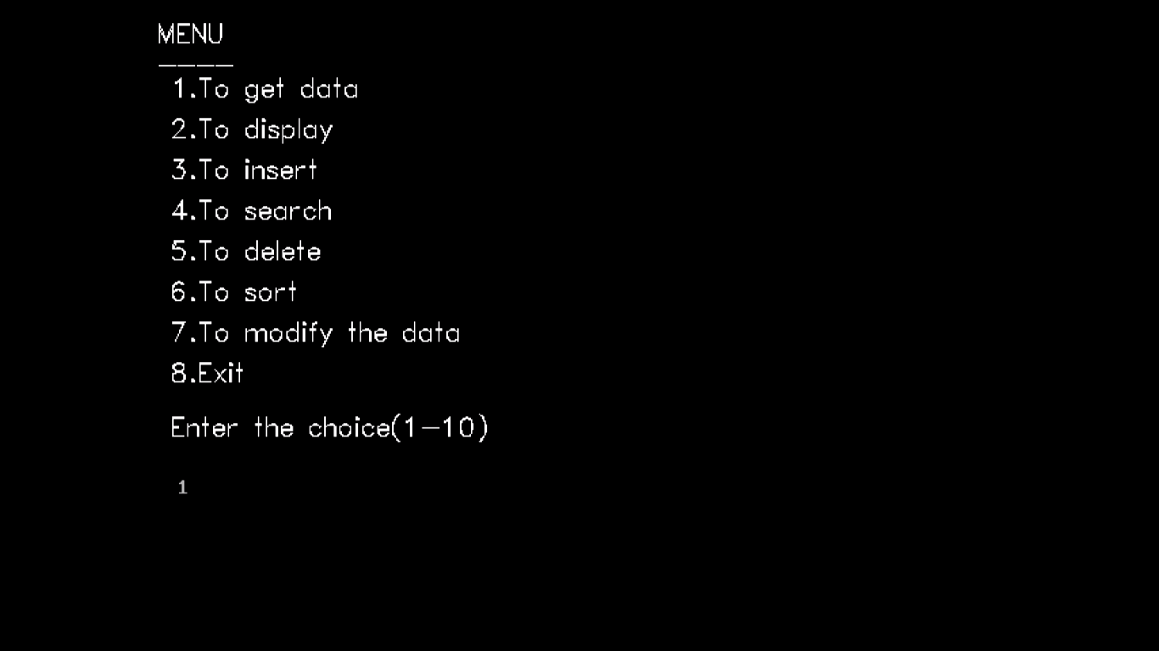

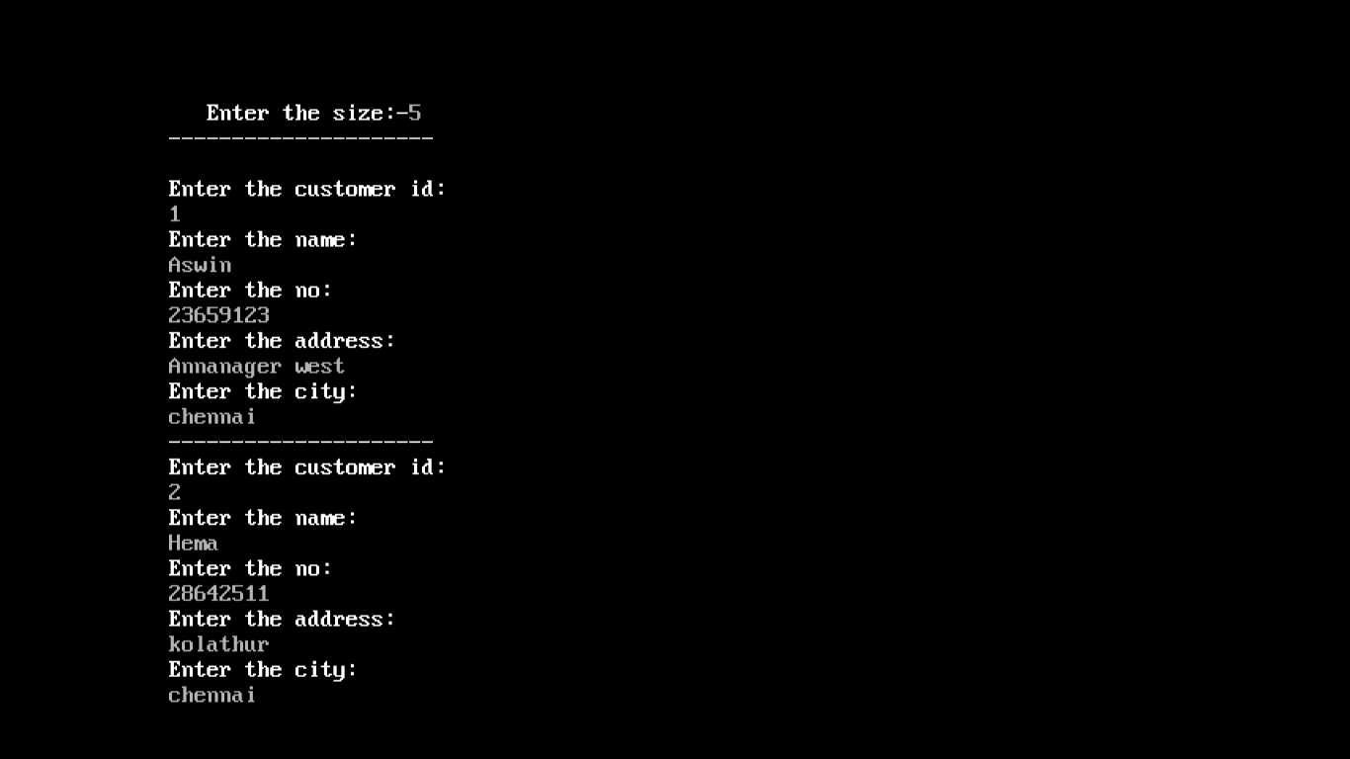

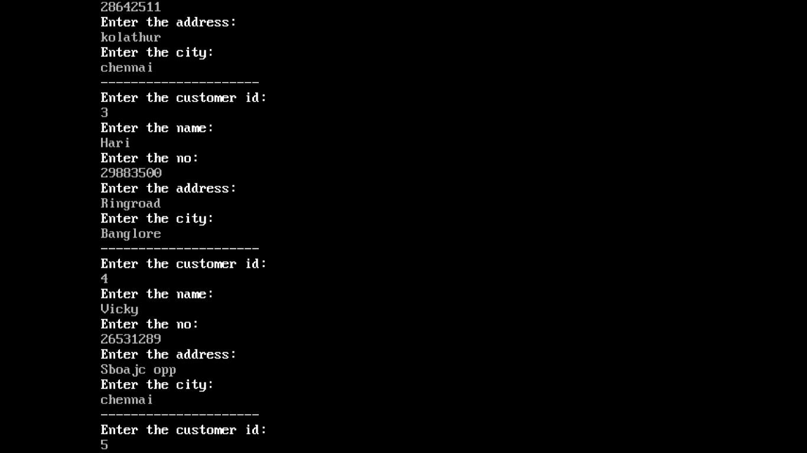

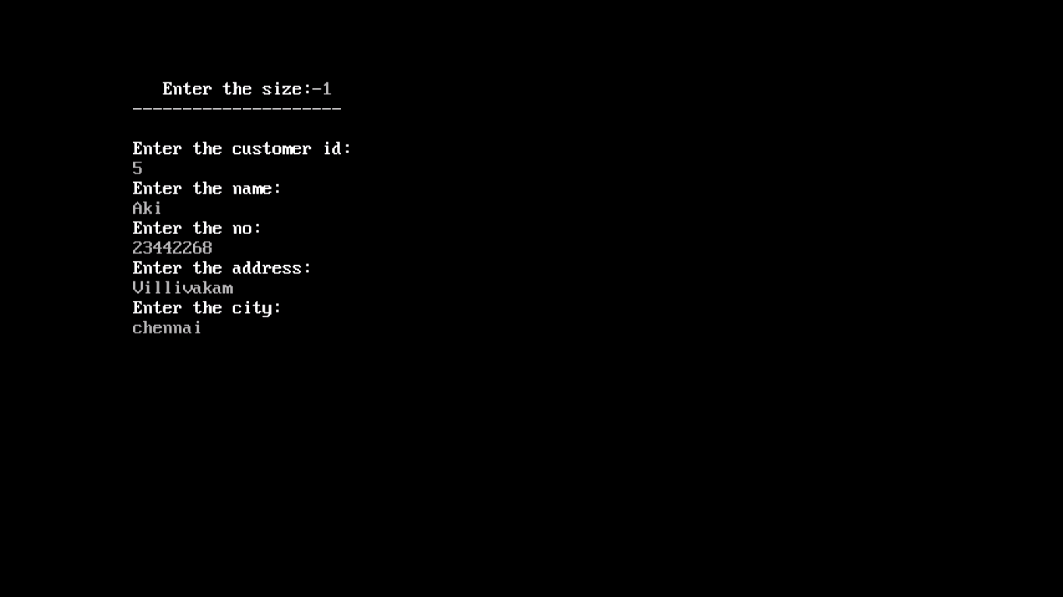



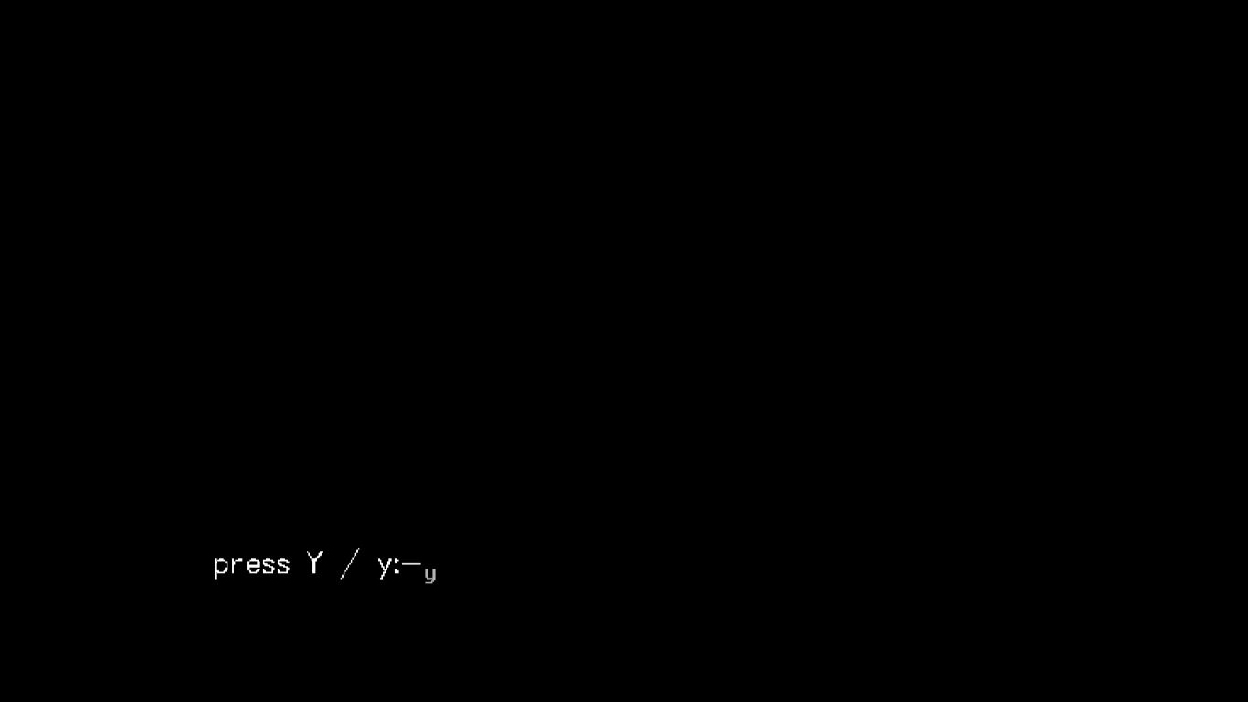

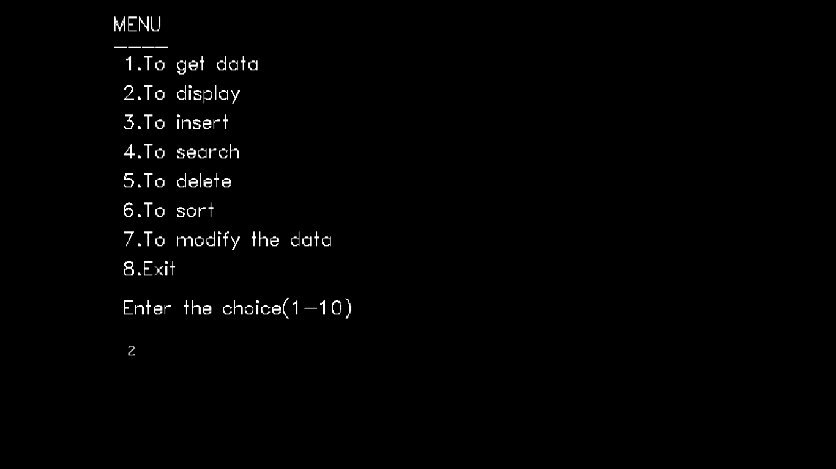

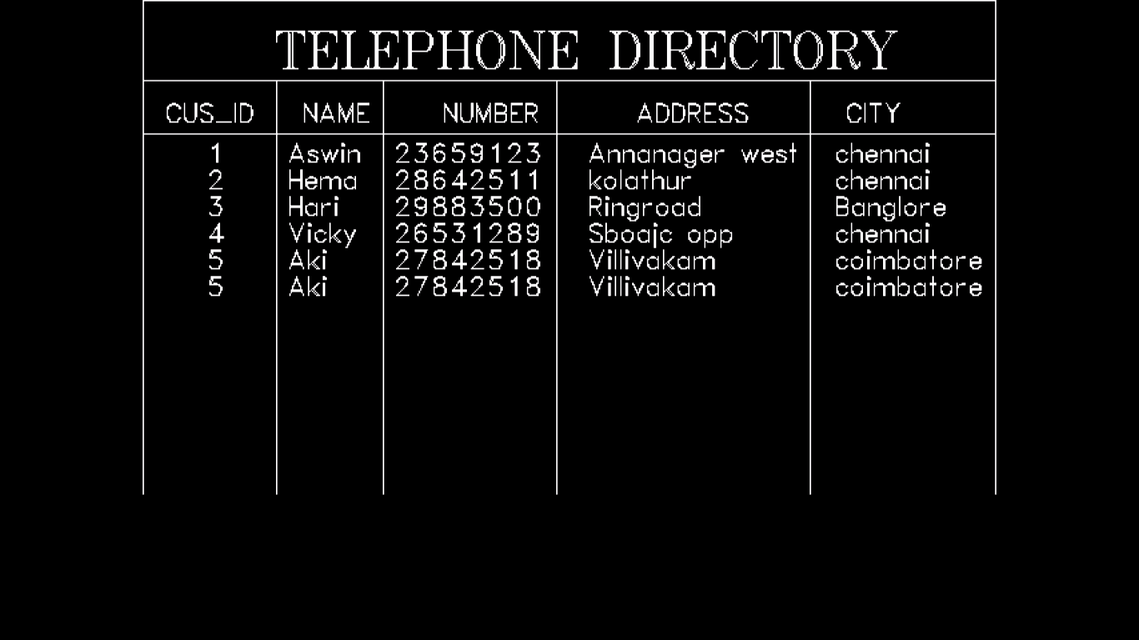



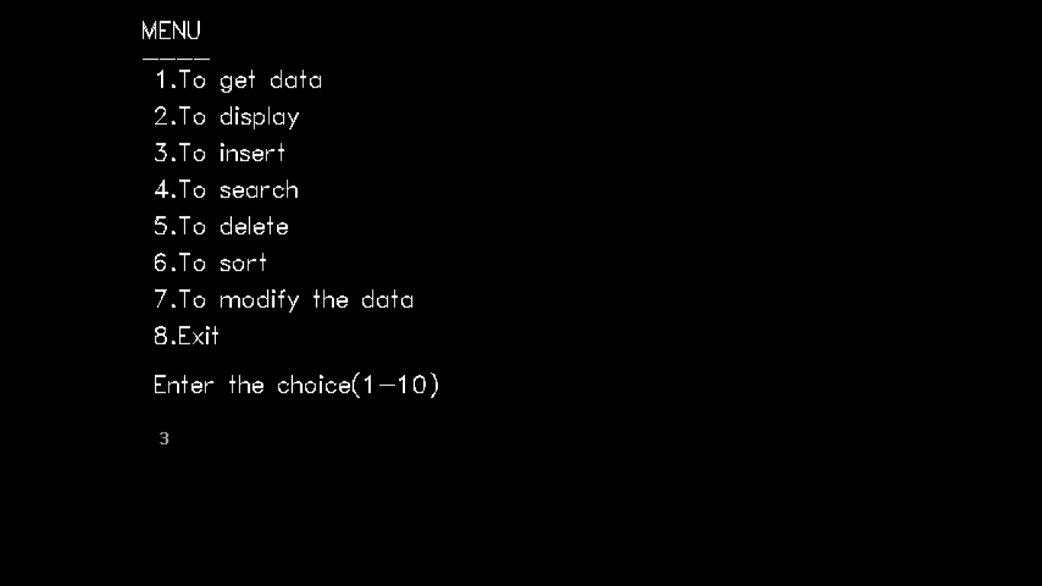

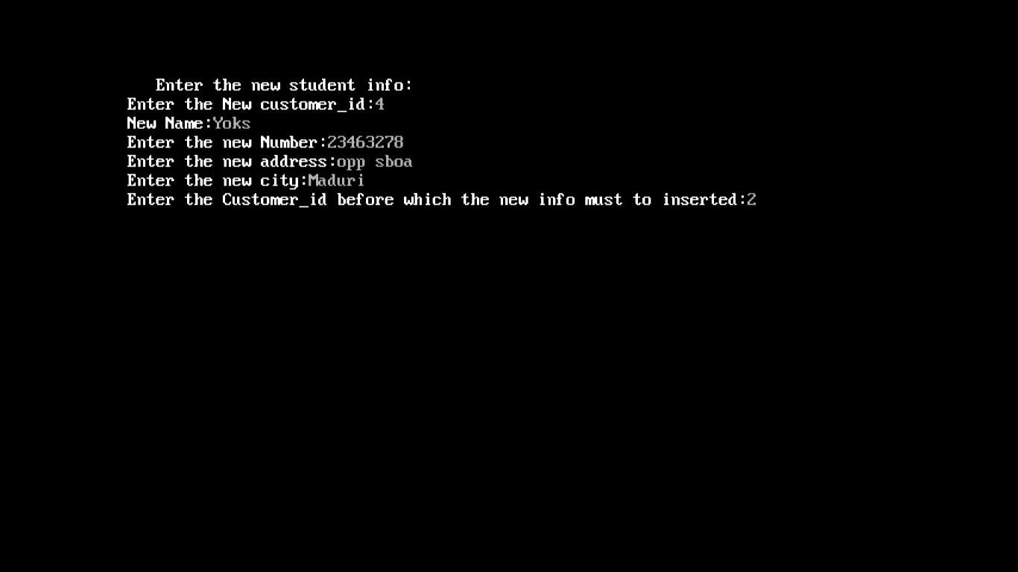





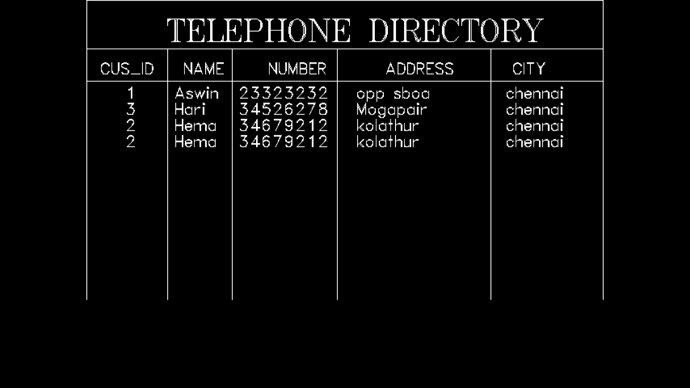



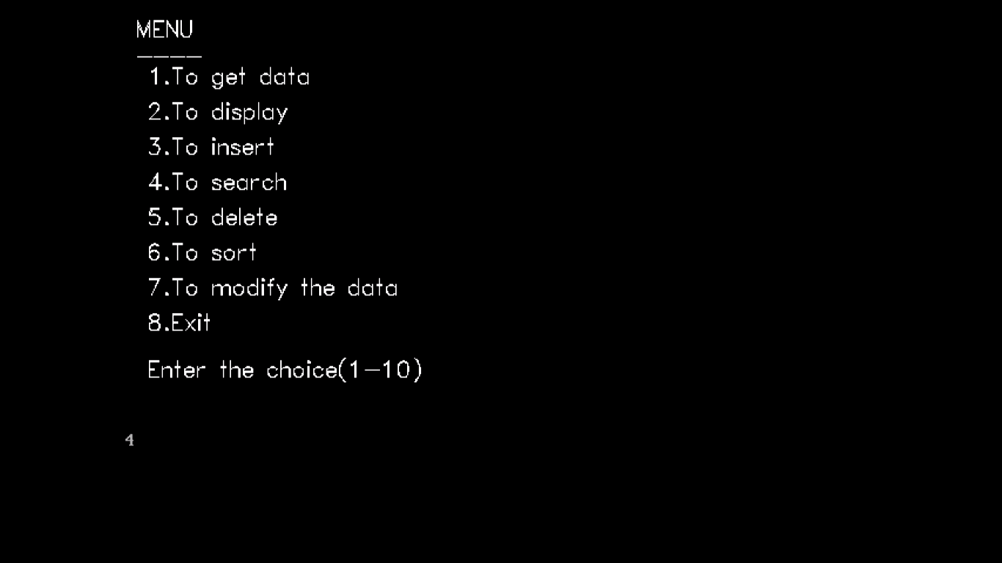

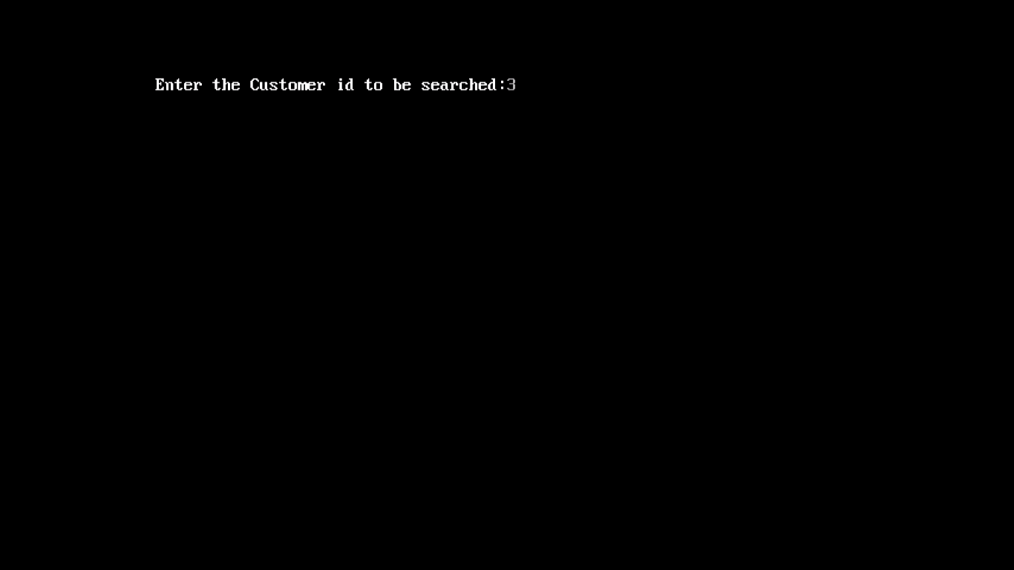

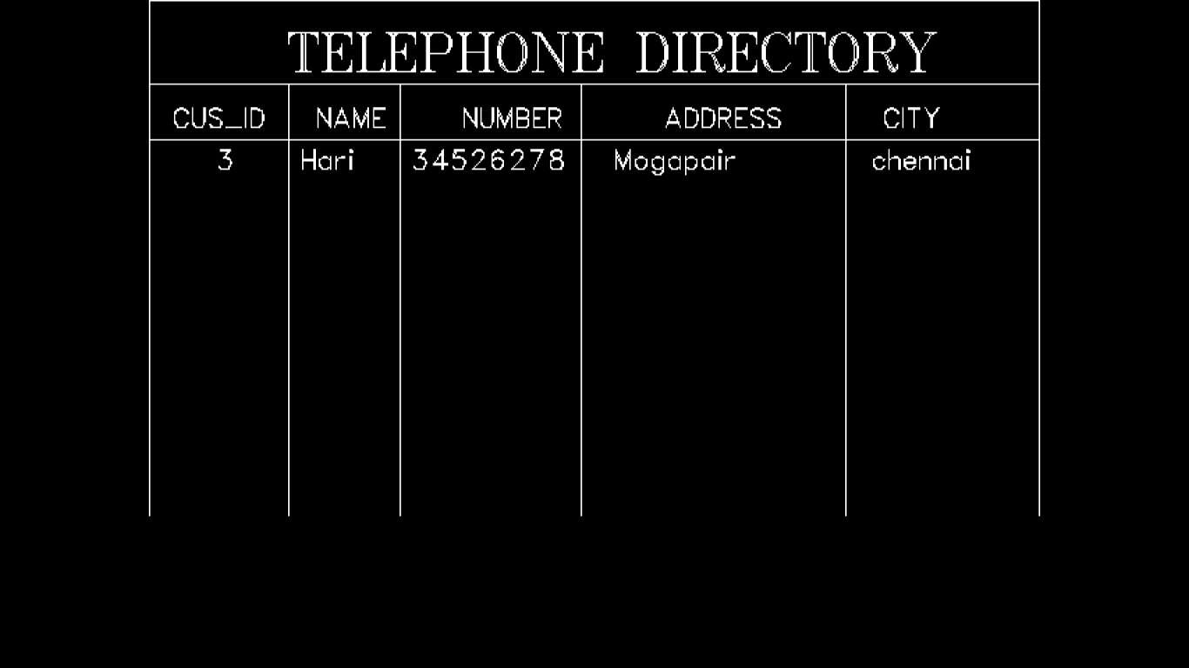



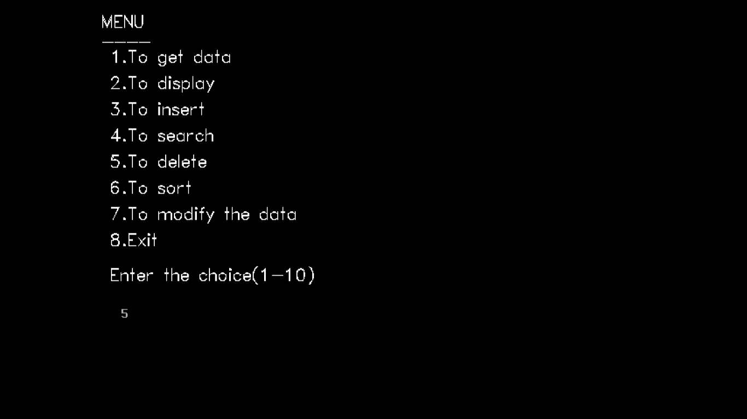

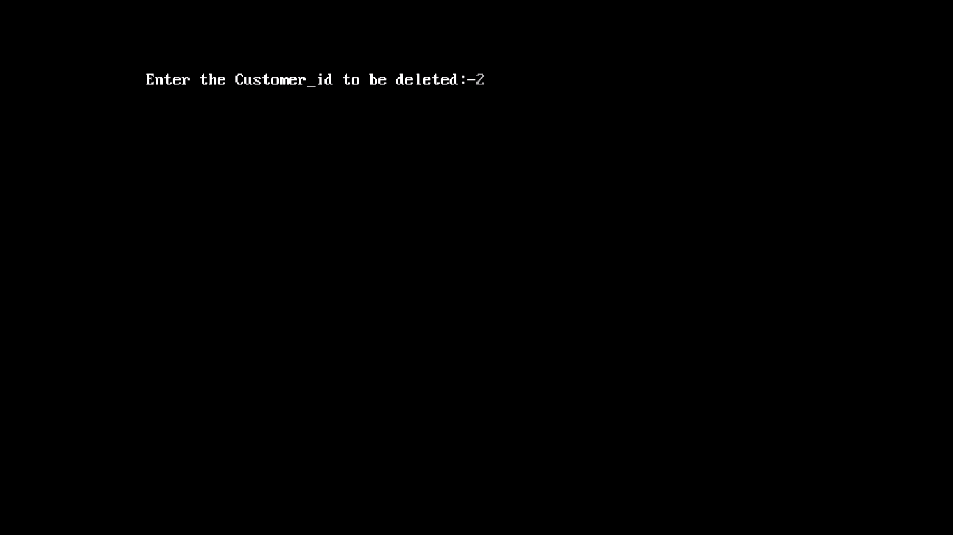



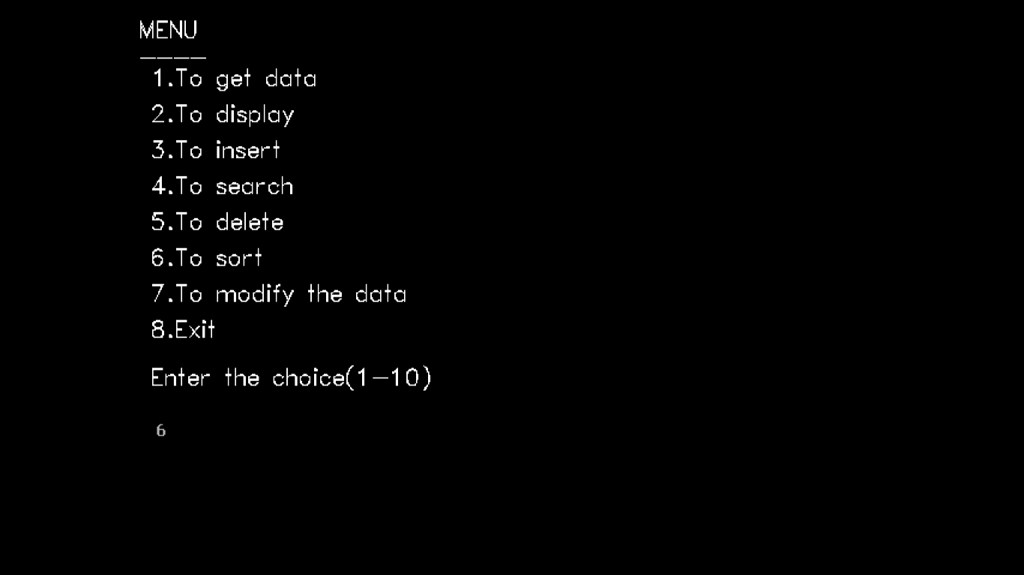

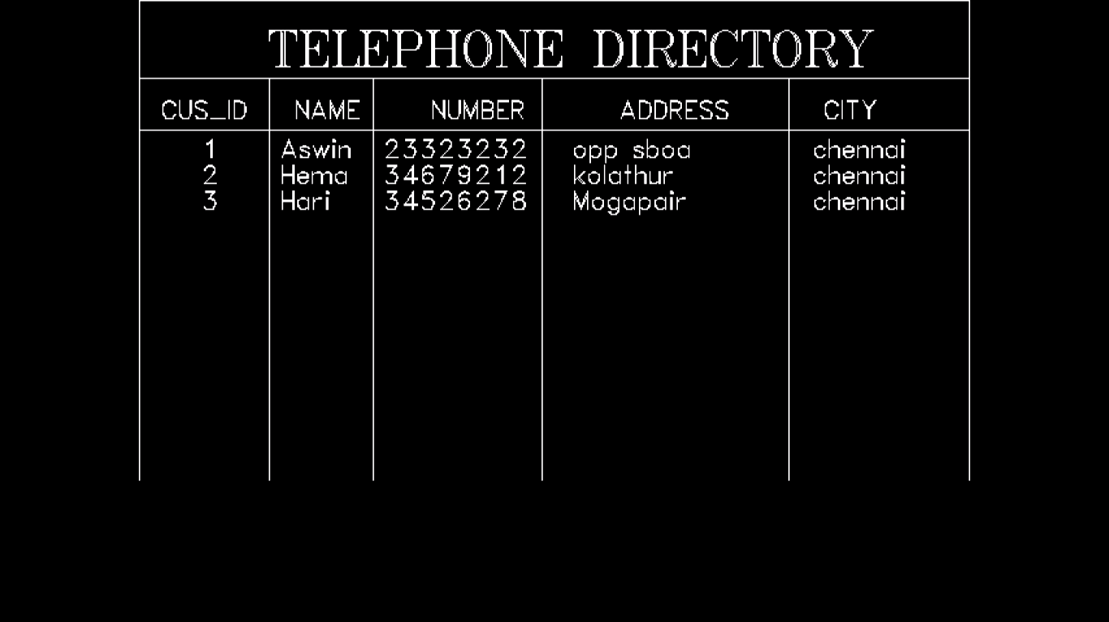



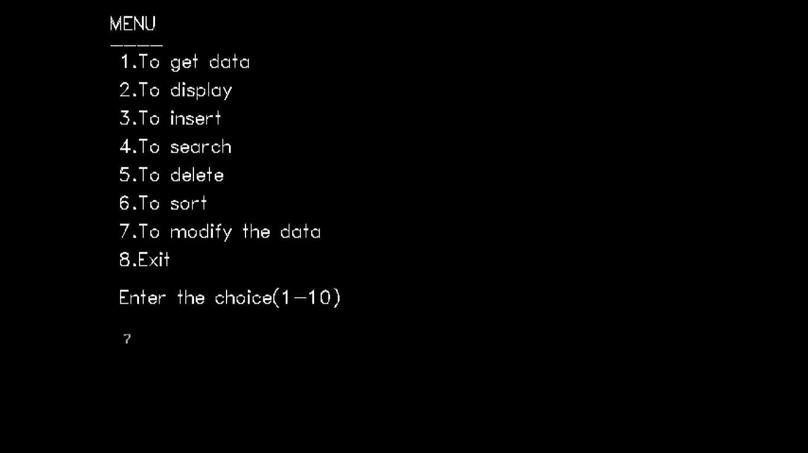

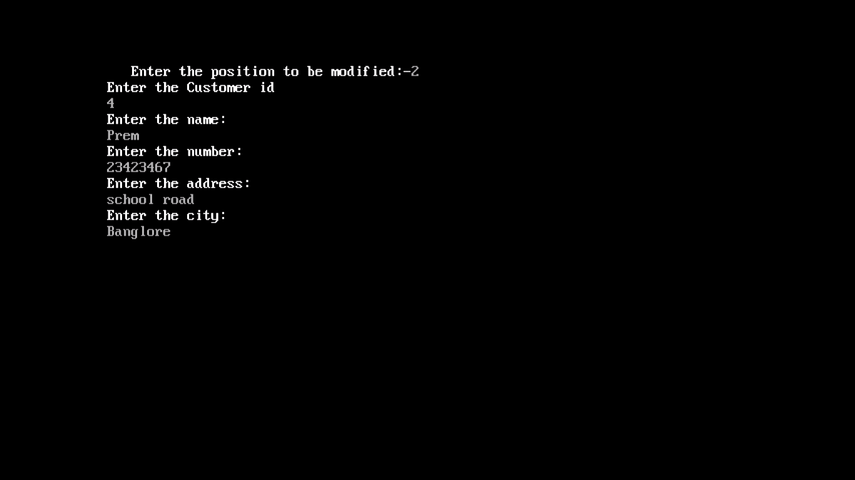





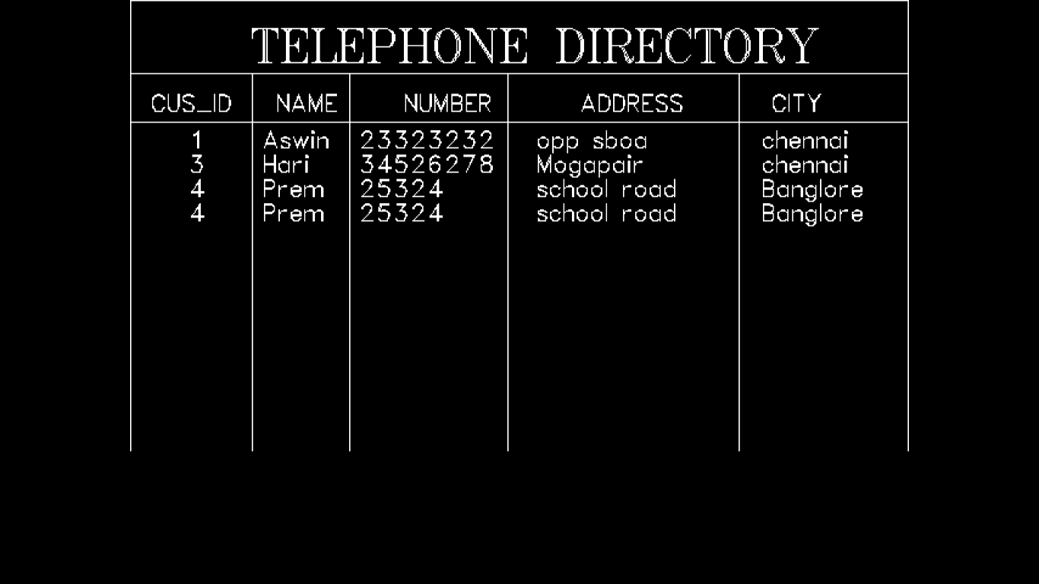



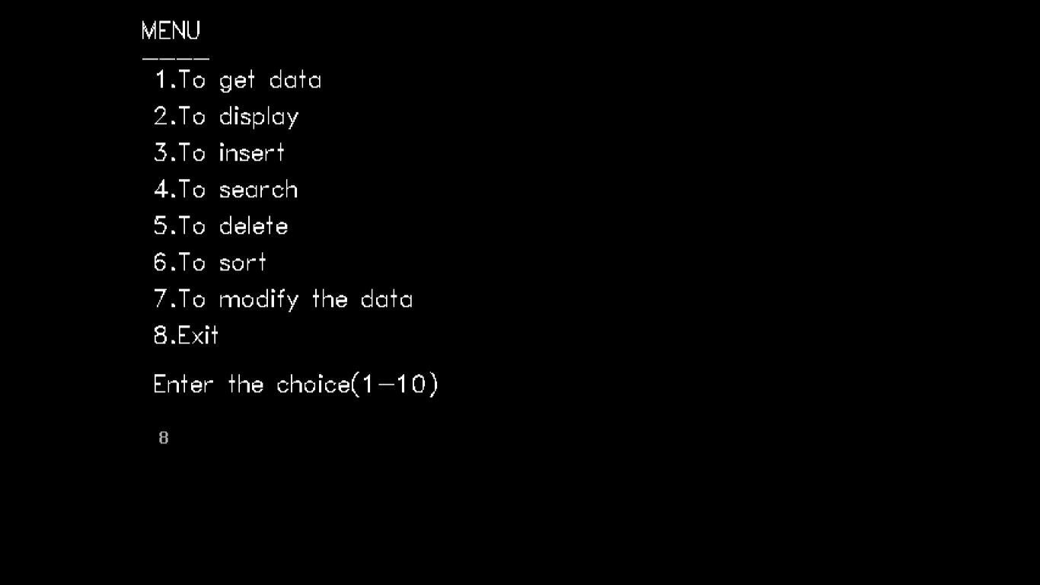

**BILIOGRAPHY**

* Computer Science with C++ (Part I) – Sumita Arora
* Computer Science with C++ (Part II) – Sumita Arora
* Introduction to C++ Programming with Graphics – C – Pozrikidis
* www.google.com
* www.quora.com